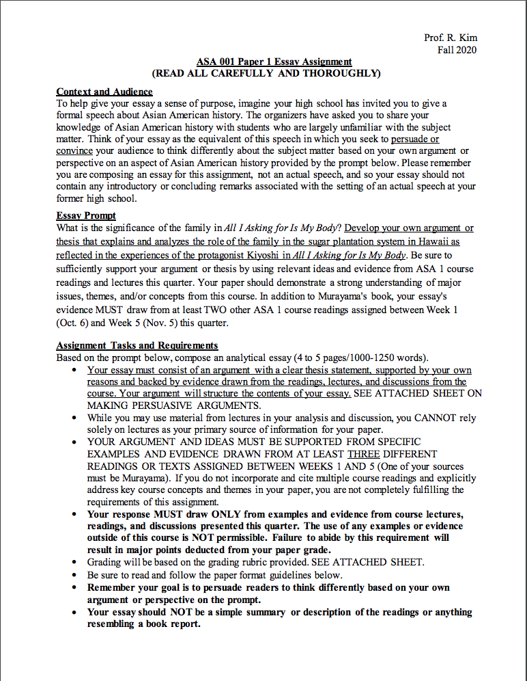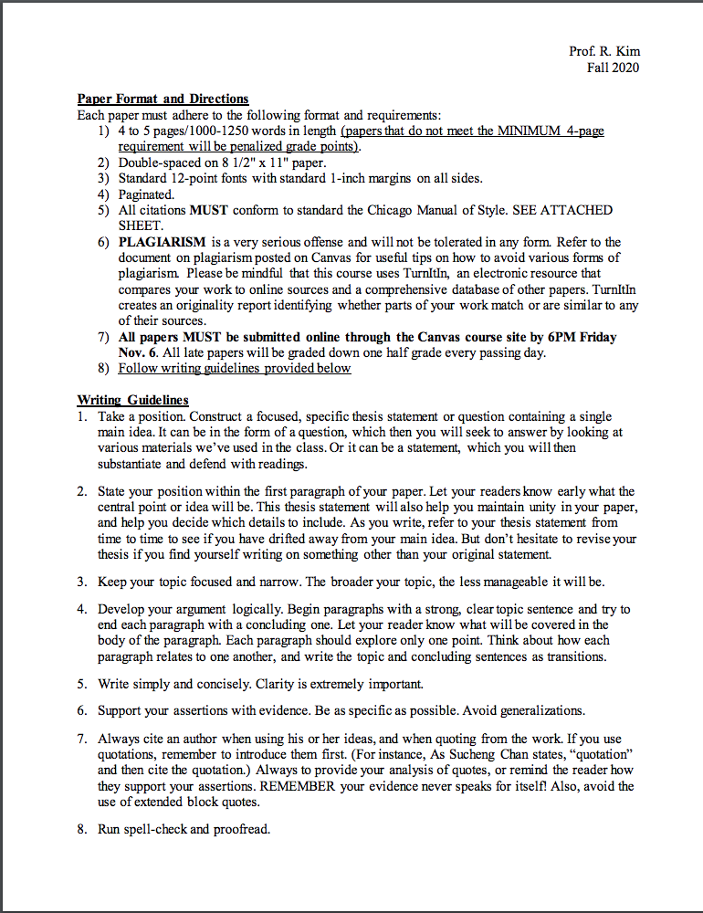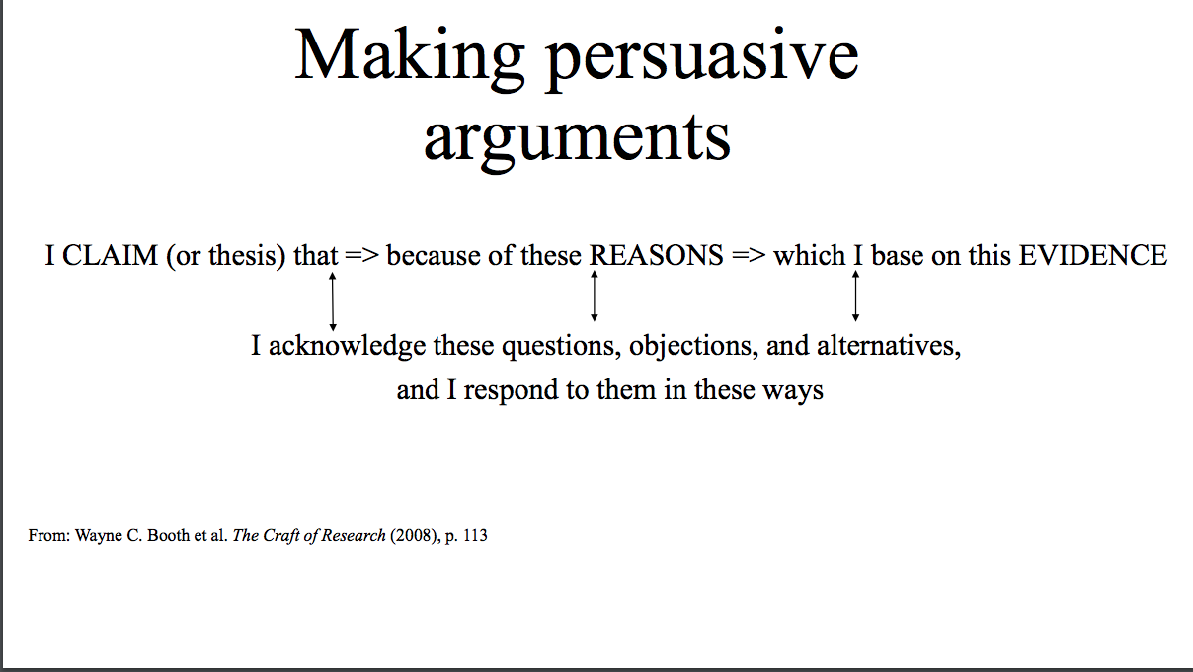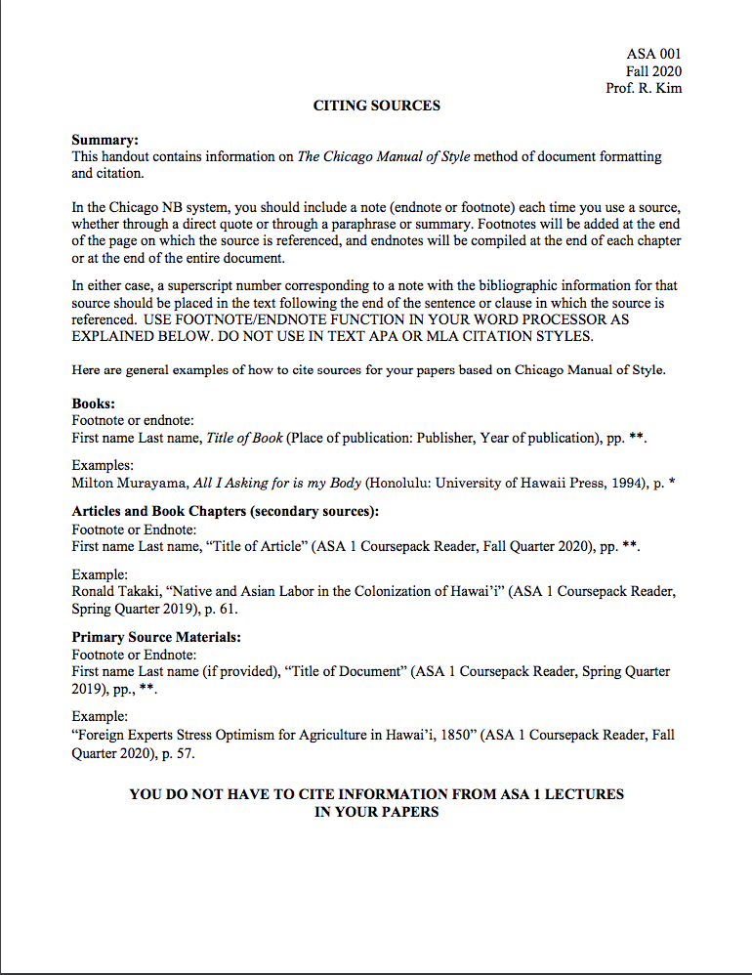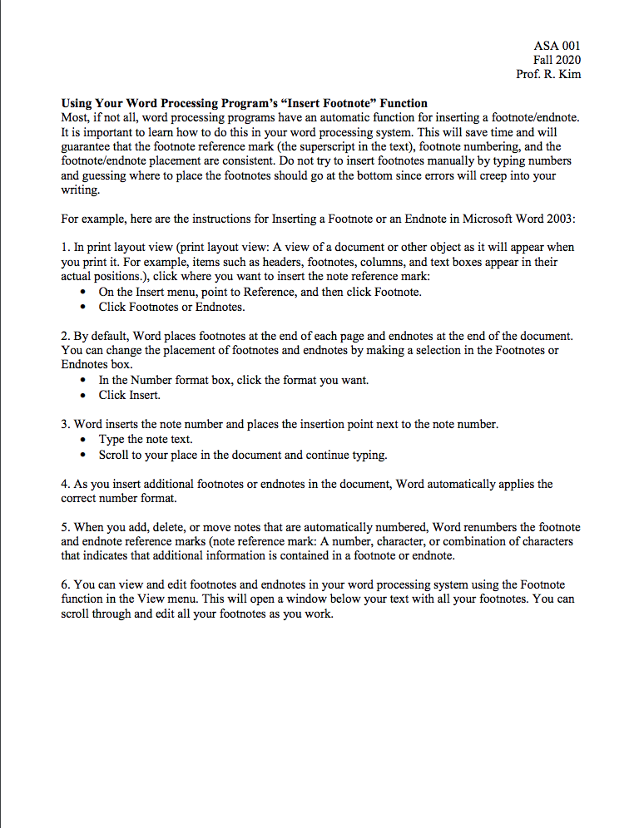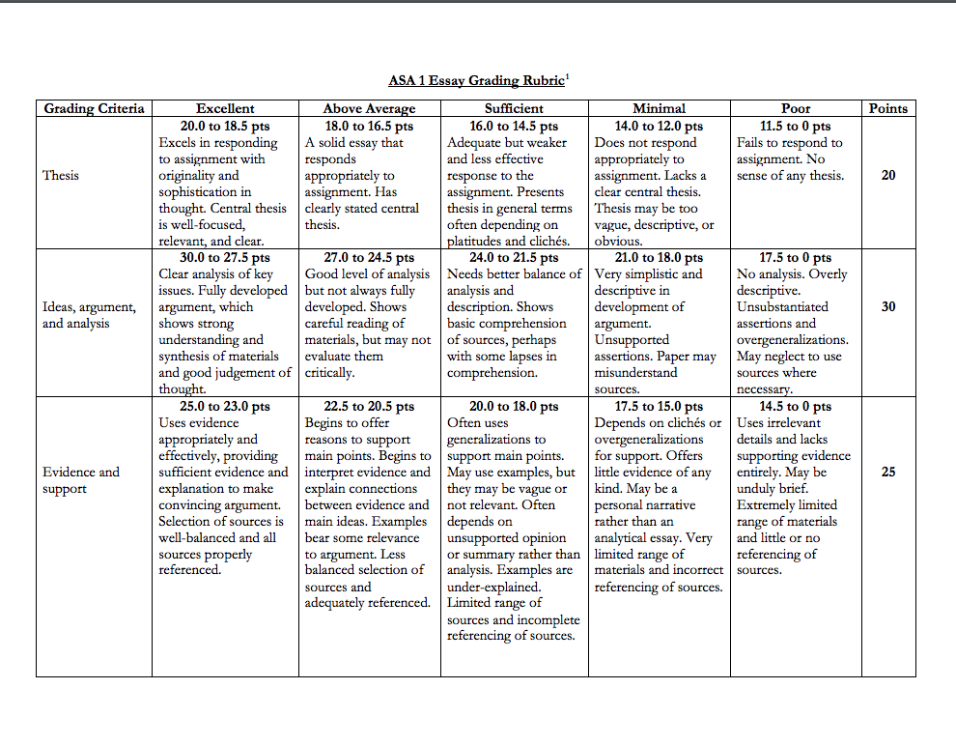

ADDITIONAL INFORMATION:

TO ACCESS THE DIGITAL BOOKS ALL I ASKING FOR IS MY BODY BY MILTON MURAYAMA, YOU NEED TO FOLLOW THESE STEPS

1. https://archive.org/details/alliaskingforis000mura/page/n7/mode/2up
2. Then find login
Username: felixsergio33@gmail.com
Password: Felixsergio33
3. You will have the access to read the book

